

College Completion: Fiscal and Societal Impact
Infogram 9
Revised January 2014
Inquiries regarding information in this Infogram may be directed to John W. Schaerer, Ed.D., Talent Dividend Liaison, Chattanooga Region Talent Dividend Initiative.

COLLEGE COMPLETION: FISCAL AND SOCIAL IMPACT
Introduction

Educational attainment is correlated to economic prosperity at all socioeconomic levels—local, state, regional, national, and, global. When Milken Institute researchers Ross C. DeVol, I-Ling Shen, Armen Bedroussian, and Nan Zhang (2013) studied economic growth in 261 metropolitan areas during the years 1990 to 2010, they ascertained that 70% of the variation in real gross domestic product (GDP) per capita could be explained in terms of education. Simply stated, a better-educated workforce yields larger benefits. According to DeVol, Shen, Bedroussian, and Zhang, “adding one year of schooling to the average educational attainment among employed workers with at least a high-school diploma is associated with an increase in a real GDP per capita of 17.4% and an increase in real wages per worker of 17.8%” (p. 1).
In general, when compared to other advanced economies, the average number of years of schooling among Americans who are 15 and older has been decreasing over the past several years. DeVol and his colleagues assert that “Americans 15 and older increased school attainment by 1.1 years, to 13.1 years in 2010, while other advanced economies gained 2.4 years, for 10.6 years of schooling” (p. 6). Although the United States currently is in the lead, other advanced economies are advancing rapidly.

Return on Educational Attainment
City Success
Aaron M. Renn, an urban-affairs analyst, entrepreneur, and speaker who writes as “the Urbanophile,” reports that “it’s almost a truism that one of the most important drivers of urban success is educational attainment” (¶2, 2010). Defining adults as 25 years or older, Renn noted that from 2006 to 2009 less than 5% of the adult populations of Detroit, Michigan, and Cleveland, Ohio, had earned a bachelor’s degree or higher. During the same period, more than 40% of the adult population of Minneapolis, Minnesota, and almost 40% of the adult population of St. Paul, Minnesota, had earned a bachelor’s degree or higher. By comparison, the percentage of adults with a bachelor’s degree or higher in the entire United States was less than 30%.
The increase in post-secondary education for Detroit and Cleveland from 2000 to 2010 was 2% for Detroit and 3.8% for Cleveland. Increases for Minneapolis and St. Paul were 9.4% and 8.1%, respectively. The increase for the United States as a whole was about 4.7%. Whereas Cleveland and Detroit had failed to keep pace with the nation, St. Louis experienced a strong increase of 11.4% (Schaerer, 2014). Clearly, educational attainment contributes to the economic strength of these cities.

State Success
Joe Cortright (2010) is president and principal economist for Impresa, a Portland (Oregon) consulting firm specializing in regional economic analysis, innovation, and industry. Cortright examined how educational growth affects gross domestic product on a statewide level. “Oregon’s system of public finance,” Cortright reports, “is profoundly shaped by the education attainment of its population” (p. 2). Although most of the state’s spending is for services for individuals with a high-school diploma or less, most of the state’s revenue comes from individuals who hold a bachelor’s degree. Cortright suggests conducting a thought experiment, such as the one described here: If we were to move 10,000 Oregonian adults from having just a high school diploma to completing a four-year college degree, we would expect state income tax receipts to rise by $8 million annually and the cost of key public service programs to decline by about $9 million annually.

Real Gross Domestic Product and Real Wages

Figure 1a and Figure 1b show the impact of educational attainment on the hypothetical economic return between real GDP per capita and real wages per capita. Projections of real GDP per capita in Tennessee-Georgia metropolitan statistical area (MSA) ranges from $39,525 in 2011 to $40,160 in 2025. The figures assume at least a 1% increase in citizens achieving either an associate-of-arts degree (A.A.) or a bachelor-of-arts or bachelor-of science degree (B.A. or B.S.). Hypothetical real wages per worker range from $28,297 in 2010 to $28,658 in 2025. The average number of years of schooling from 2010 to 2025 reflects a hypothetical gain of 0.143. Because the data are based on an increase of only 1% in an A.A. and a B.A. or B.S. degree, they reflect a minimal impact. As Figure 1c shows, the actual number of additional individuals achieving associate’s and bachelor’s degrees varies from 4,902 in Cycle 1 (2011–2013) to 25,098 in Cycle 5 (2023–2025). Although marginal attainment is illustrated, it is clear that educational attainment has a positive impact on economic growth.
Higher-education institutions must offer degree programs that support current and future business and industry. And in order to keep college graduates local—as well as to attract and retain a quality workforce—a given region must provide an attractive job market, including the recruiting an appropriate mix of employment opportunities. As the demise of a once-robust city such as Detroit demonstrates, focusing only on immediate employment needs may sacrifice long-term prospects (DeVol, Shen, Bedroussian, and Zhang, 2013).

Figure 1a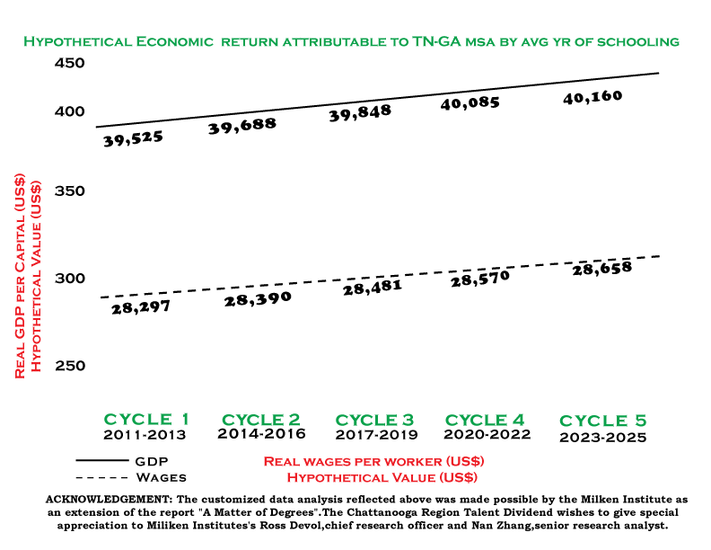

Figure 1b
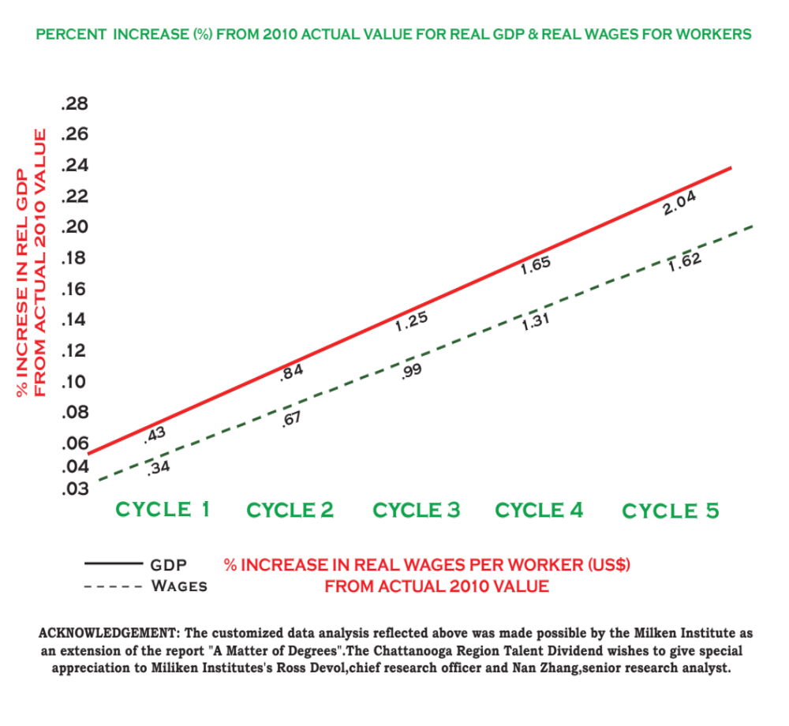

Cycle | Associate’s  Degree | Bachelor’s  Degree | Per-Cycle  Increase | Associate’s  (Cumulative) | Bachelor’s  (Cumulative) | Cycle Increase  (Cumulative)
Cycle 1  2011-2013 | 1,470 | 3,432 | 4,902 | 1,470 | 3,432 | 4,902
Cycle 2  2014-2016 | 1,470 | 3,432 | 4,902 | 2,940 | 6,864 | 9,804
Cycle 3  2017-2019 | 1,500 | 3,500 | 5,000 | 4,440 | 10,364 | 14,804
Cycle 4  2020-2022 | 1,529 | 3,569 | 5,098 | 5,969 | 13,933 | 19,902
Cycle 5  2023-2025 | 1,559 | 3,637 | 5,196 | 7,528 | 17,570 | 25,098
Figure 1c

Projections (Objectives) for Post-Secondary Degree Attainment
(8,170 by 2015 and 30,008 by 2025)

Chattanooga Region Talent Dividend (16 counties in Alabama, Georgia, and Tennessee). Projections provided by Dr. John Schaerer, Talent Dividend Liaison, Chattanooga Region Talent Dividend.

College Attainment and Lifetime Impact

Philip A. Trostel (2007) quantified the fiscal impact of college attainment over an average lifetime. The results, listed almost verbatim from pages 1 and 2 of Trostel’s report, are as follows:
• State income taxes increase by approximately $52,500
• Local property taxes increase by $38,000
• State and local sales taxes increase by more than $27,000
• Federal income taxes increase by $238.000
• Federal payroll taxes increase by $115,500 (Total tax revenue increased by approximately $471,000)
• Various forms of public assistance decrease by more than $10,000
• Medicaid benefits decrease by almost $21,000
• Medicare benefits decrease by $9,500
• Social-security benefits decrease by $9,000
• Supplemental security income payments decrease by almost $6,000
• Unemployment compensation decreases by more than $1,5000
• Workers compensation decreases by $1,500
• Spending on corrections decreases by more than $21,000
• Spending on public health decreases by almost $5,000
• Total government spending on higher education is about $74,500 per
degree from public college (Total government spending decreases by $10,000 per degree from public institutions)
The lifetime net fiscal effect per degree from public institutions is more than $481,000.
Granted, it is not possible to precisely project the fiscal impact and dividend return. The approximations of fiscal impact and return, however, demonstrate a positive payoff, or dividend. The Trostel working-paper demonstrates clearly that fiscal benefits are evident at the state level. When considered in light of the considerable body of knowledge reflecting similar conclusions, the preponderance of evidence corroborates the positive fiscal impact of college attainment. Because many college graduates move to other states, the fiscal impact transcends state lines and has a regional impact.
Earnings, Wealth, and Health
Higher levels of education are associated with better health across all ages and incomes. Alexandra Sifferlin (2012) reports that studies conducted by the Centers for Disease Control (CDC) determined that “in households where the head of the household had a bachelor’s degree or higher, 11% of the boys and 7% of the girls were obese. Comparatively, in homes where the head of the household had less than a high school education, 24% of the boys and 22% of the girls were obese” (¶3). Andy I. Choi, Cristin C. Weekley, Shu-Cheng Chen, Suying Li, Manjula Kurella Tamura, Keith C. Norris, and Michael G. Schlipak (2011) also note that the prevalence of conditions such as diabetes, smoking, and obesity is lower relative to higher education attainment (see Figure 2). Furthermore, adds Robert E. Johnson (2010) “educated individuals are also more likely to volunteer, vote, and raise healthier, better educated children” (¶9).
Regarding the economic advantage of higher education, Julia B. Isaacs, Isabel V. Sawhill, and Ron Haskins (2008) assert, “A college degree is increasingly the ticket to improving or maintaining one’s relevant position in the economy” (p. 7). The growth in ‘pay premium’ relevant to bachelor’s-degree attainment has grown in recent years, according to Tamar Lewin (2010): “Among those ages 25 to 34, women with college degrees earned 79% more than those with a high school diplomas, and men 74% more. A decade ago, women with college degrees had a 60% “pay premium” and men 54%” (¶4). Relative to lifespan, NewPublicHealth (2012) reports that
On average, a college graduate can expect to live five years longer than individuals who have not finished high school. Further, an additional four years of education reduces several health risks, including diabetes—1.3%; heart disease—2.2%; overweight—5%; smoking—12%. (¶3)

Additionally, AMJ Kidney Dis, 2011, August, 58(2): 228-234, reports that higher educational attainment correlates with a lower incidence in cardiovascular disease, hypertension, diabetes, and reduced kidney function.
Figure 2
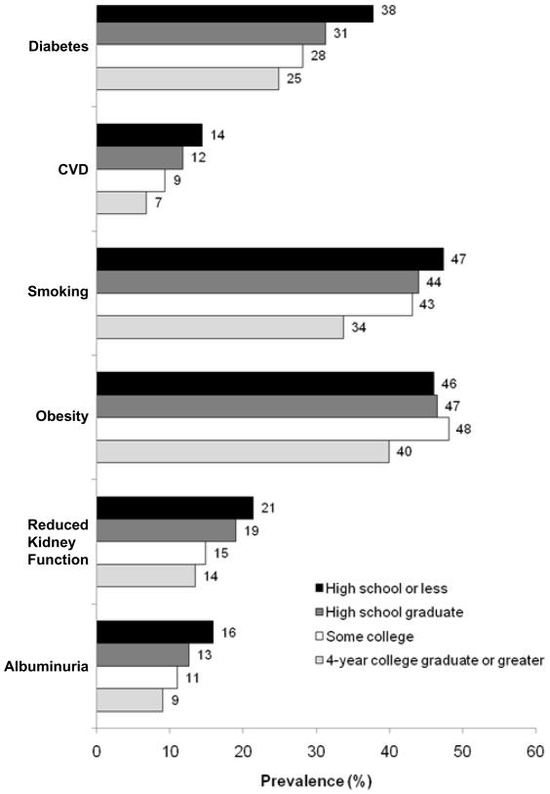
(http://www.ncbi.nlm.nih.gov/pmc/articles/PMC3144262)
Recovery 2020 and Fiscal Impact
A 2013 report from the Georgetown University Center on Education in the Workforce predicts the state of the American economy as of the year 2020. The predictions include the following items:
• Fifty-five million job openings will exist in 2020; 24 million from newly created jobs and 31 million owing to retirements
• Thirty-five percent of job openings will require at least a bachelor’s degree, 30% will require some college or an associate’s degree, and 36% will require no education beyond high school
• The fastest-growing occupations will be in science, technology, engineering, and mathematics (STEM), healthcare (professionals and support), and community service positions that require high levels of post-secondary education
• Most jobs will require some type of post-secondary education
• Employers will seek cognitive skills such as communication and analytics
• Given the current productivity rates, the United States will fall short by 5 million workers with post-secondary education
By looking forward to 2020, regional communities can be positioned, through a systematic, sustainable, quality workforce, to take advantage of these predictions.
The CEOs for Cities Talent Dividend Report (2012) explains that 58% of a city’s success is measured by per-capita income. On average, a citizen in the Tennessee-Georgia MSA who achieves a bachelor’s degree and above generates approximately $104 thousand annually. An increase of at least 1% gain in citizens with a bachelor’s degree and above in the greater-Chattanooga 16-county tri-state region results in a projected collective impact of $850 million annually. According to the CEOs for Cities report, “each additional percentage point of improvement in adult four-year college attainment is linked with $763 increase in per capita income” (¶1).

Geospatial Mapping
Geospatial mapping indicates that Tennessee’s 16-county tri-state region reflects a mix of educational attainment and, therefore, an inferred mix of fiscal and societal impacts. Examination at the county level is even more revealing and specific regarding the fiscal and societal impact of educational attainment. This methodology has not been applied to all 16 counties. For the purpose of this article, however, I have applied the methodology to Hamilton County, Tennessee (see Figure 3). Figure 4 provides more detail by showing educational attainment by commission district within Hamilton County. Figure 5 illustrates the economic impact of at least a 1% gain in college completers based on an average per capita salary increase of $763. And Figure 6 shows economic impact total for all commissioner districts at $462.328 and the proportionate percentage by each elected commissioner.
Information presented in this Infogram describes educational attainment and its positive fiscal and societal impacts, and it does so from a perspective that ranges from the local level to the national level. It seems obvious that whereas maintaining the status quo is limiting, adopting a dynamic approach to developing a systematic, sustainable, quality workforce is imperative for ongoing economic prosperity.

Figure 3
Hamilton County Map
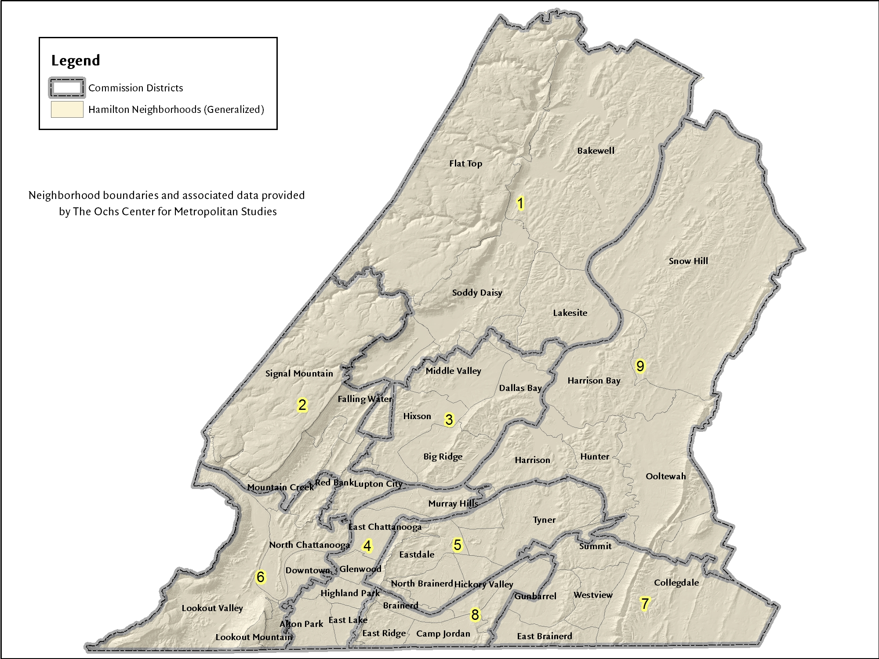

Figure 4
Educational Attainment by District:
Hamilton County, Tennessee

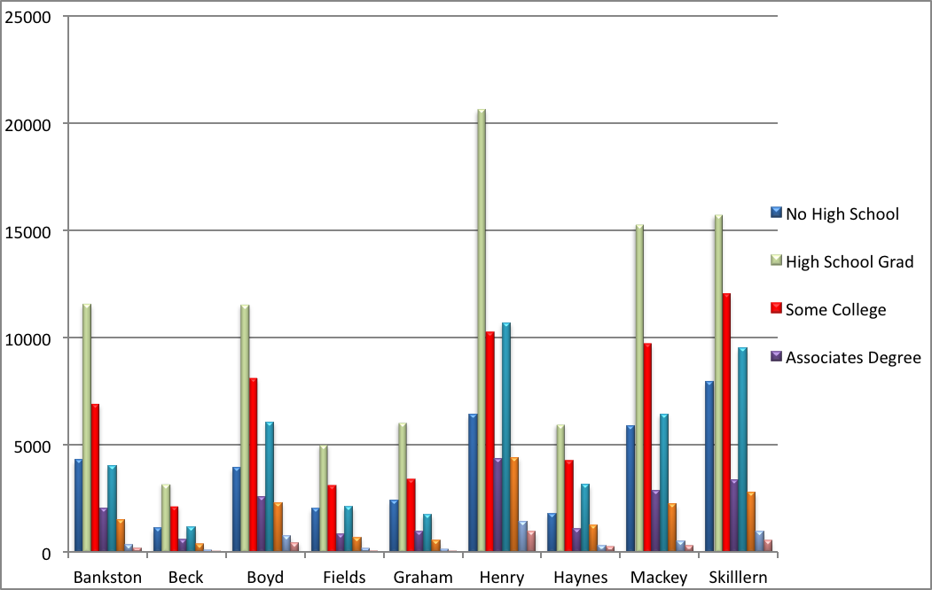
Figure 5

Chattanooga Talent Dividend, Hamilton County:
Economic Impact of 1% Gain (Per Capita = $763)

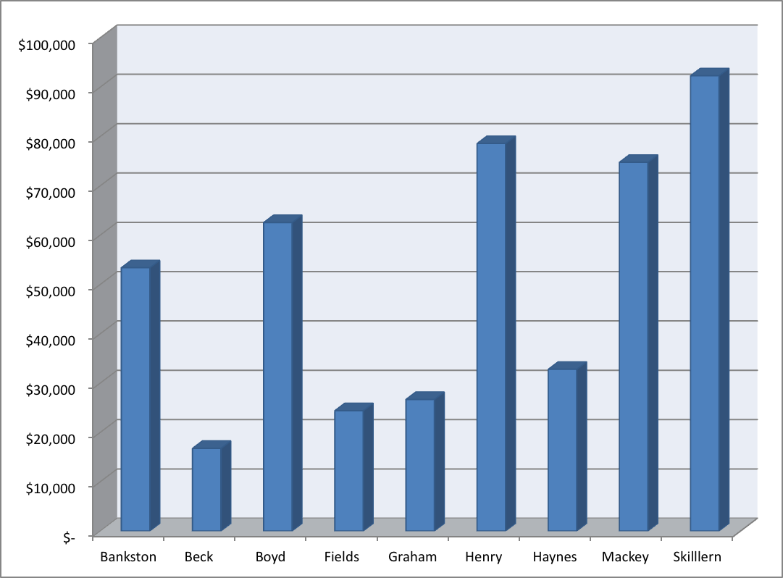

Figure 6

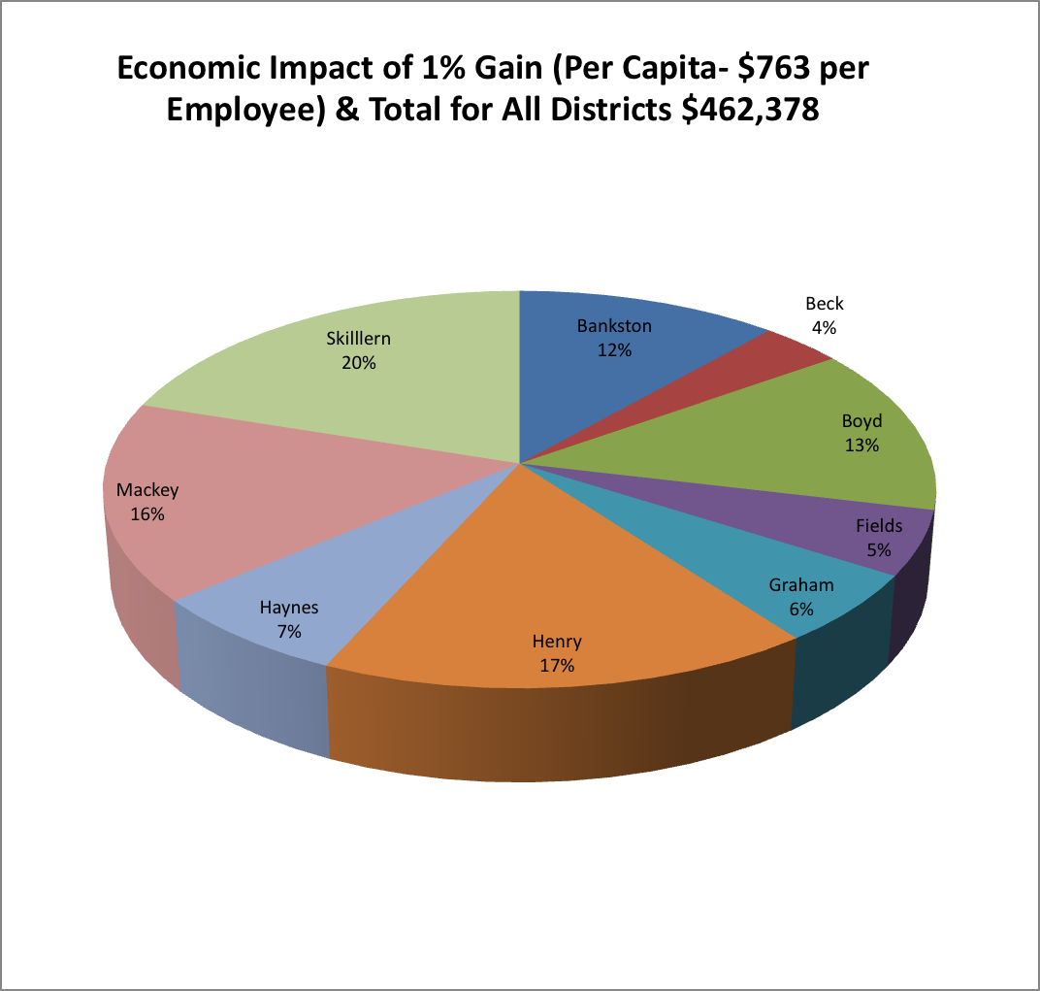

Incarceration, Unemployment, and Earnings

The cost of maintaining adults in prisons, jails, and youth-detention centers and of monitoring 7.3 million probationers and parolees costs U.S. taxpayers approximately $70 billion annually. Imprisonment costs at the local and state levels deplete education and other public-needs funds, including housing, healthcare, and public assistance, asserts Steven Hawkins (2010). Seventy-five percent of imprisonment costs occur at the state level.
According to the Bureau of Labor Statistics (2012), individuals with more education are less likely to be incarcerated. Statistics for 2008 show an association regarding incarceration and unemployment relative to educational attainment. Individuals with more education (high-school graduation, 1 to 3 years of college, or a
4-year college degree) represent the lowest percentage of incarcerated individuals (American Community Survey, 2011). It must be noted, however, that—regardless of educational attainment—large numbers of individuals are incarcerated and unemployed and that the patterns associated with incarceration are evident. It may be argued that more money invested in education may help, particularly regarding regions with high concentrations of poverty and depressed support resources. In general, other arenas may be considered, such as the transformation of expenditures relevant to current policies practices. Figure 8 shows unemployment and earning rates for 2012.

Figure 7

Incarceration Impact

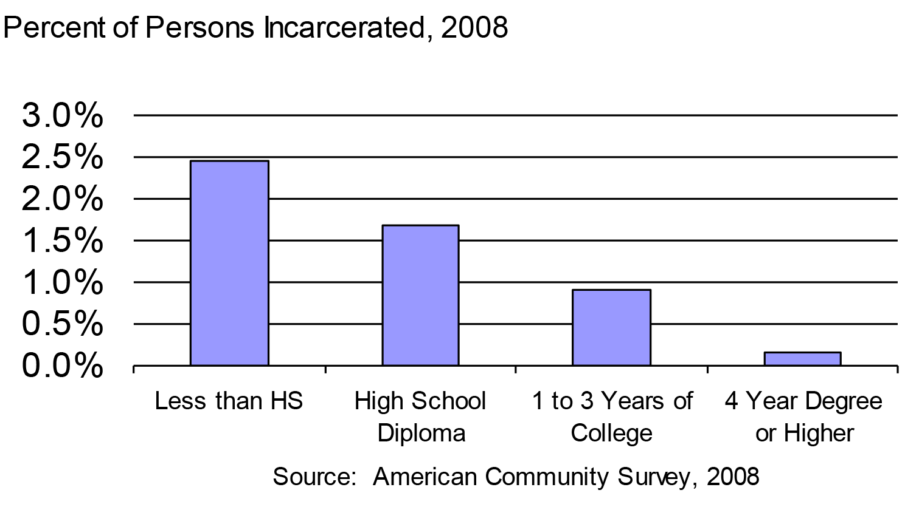
Figure 8
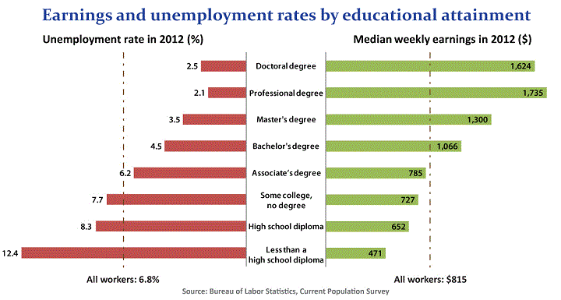
Note: Data are for persons age 25 and over. Earnings are for full-time wage and salary workers.

Efficiency and Effectiveness
Educational attainment is not precise for the pathology of incarceration or employment. Educational attainment does, however, contribute to an aversion to risks and improves potential success. Efficiency and effectiveness of higher education initiatives regarding the production of quality completers on a timely basis is a place to begin transformation. In other words, it might be advantageous for education institutions to first transform practices, policies, and operations that produce improved results by adjustments in the utilization of resources on hand. More of the same is not good enough. For example, graduation rates indicate that investing in education is transformational. The following tables illustrate that fact.
PUBLIC COLLEGE (4-year)
STATE | Percentage who graduate in 4 years | Percentage who graduate in 6 years | Average spending per academic award | Efficiency completion per 100 students
ALABAMA | 22.9% | 47.5% | $84,304 | 17.9
GEORGIA | 24.0% | 51.6% | $55,093 | 17.9
TENNESSEE | 19.7% | 45.5% | $76,508 | 18.3
ALL STATES | N/A | N/A | $65,617 | N/A

PUBLIC COLLEGE (2-YEAR)
STATE | Percentage graduated in 100% of time | Percentage graduated in 15% of time | Includes all certificates and degrees. Avg. per academic award | Includes all certificates and degrees. Efficiency completing per 100 Students
ALABAMA | 12.2% | 19.1% | $47,902 | 13.7
GEORGIA | 17.0% | 25.1% | $17,999 | 14.4
TENNESSEE | 8.0% | 11.3% | $47,537 | 13.2
ALL STATES | N/A | 20.4% | $42,759 | 14.2

Source: The Chronicle of Higher Education, 2010 Graduation Rates Undergraduates, www. collegecompletion@chronicle.com)

Based on these tables, how is it that Georgia has the lowest average spending per academic award compared to Alabama and Tennessee, yet it has the highest percentage of graduates among 4-year and 2-year institutions?
Businesses and Competent Skilled Employees
Businesses require qualified graduates. When researchers at Georgetown University studied job growth through 2020, they reported that, regardless of the discipline of the educational degree, businesses are requesting specific skills in addition to general competency. The most-valued skills include analysis, communication, and leadership. Indeed, 96% of all the occupations studied indicated that active listening and critical thinking are critical. Figure 9 illustrates the distribution of such skills by occupation.
Figure 9
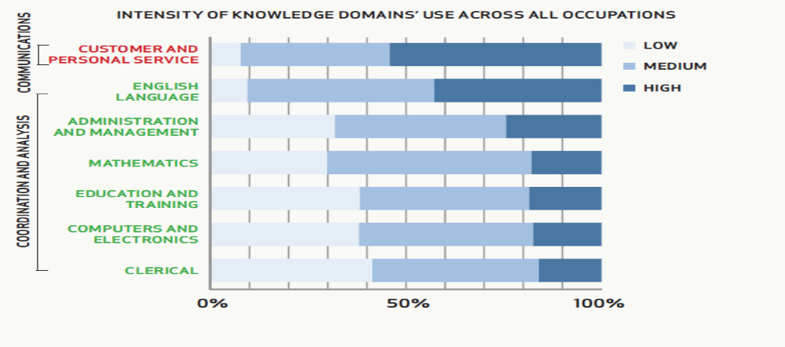
John Dorris (2011), of the University of Tennessee at Chattanooga provides further evidence of the need for essential skills. Figure 10 shows national and local Chattanooga-area rankings.

Figure 10
Critical Workforce Skills
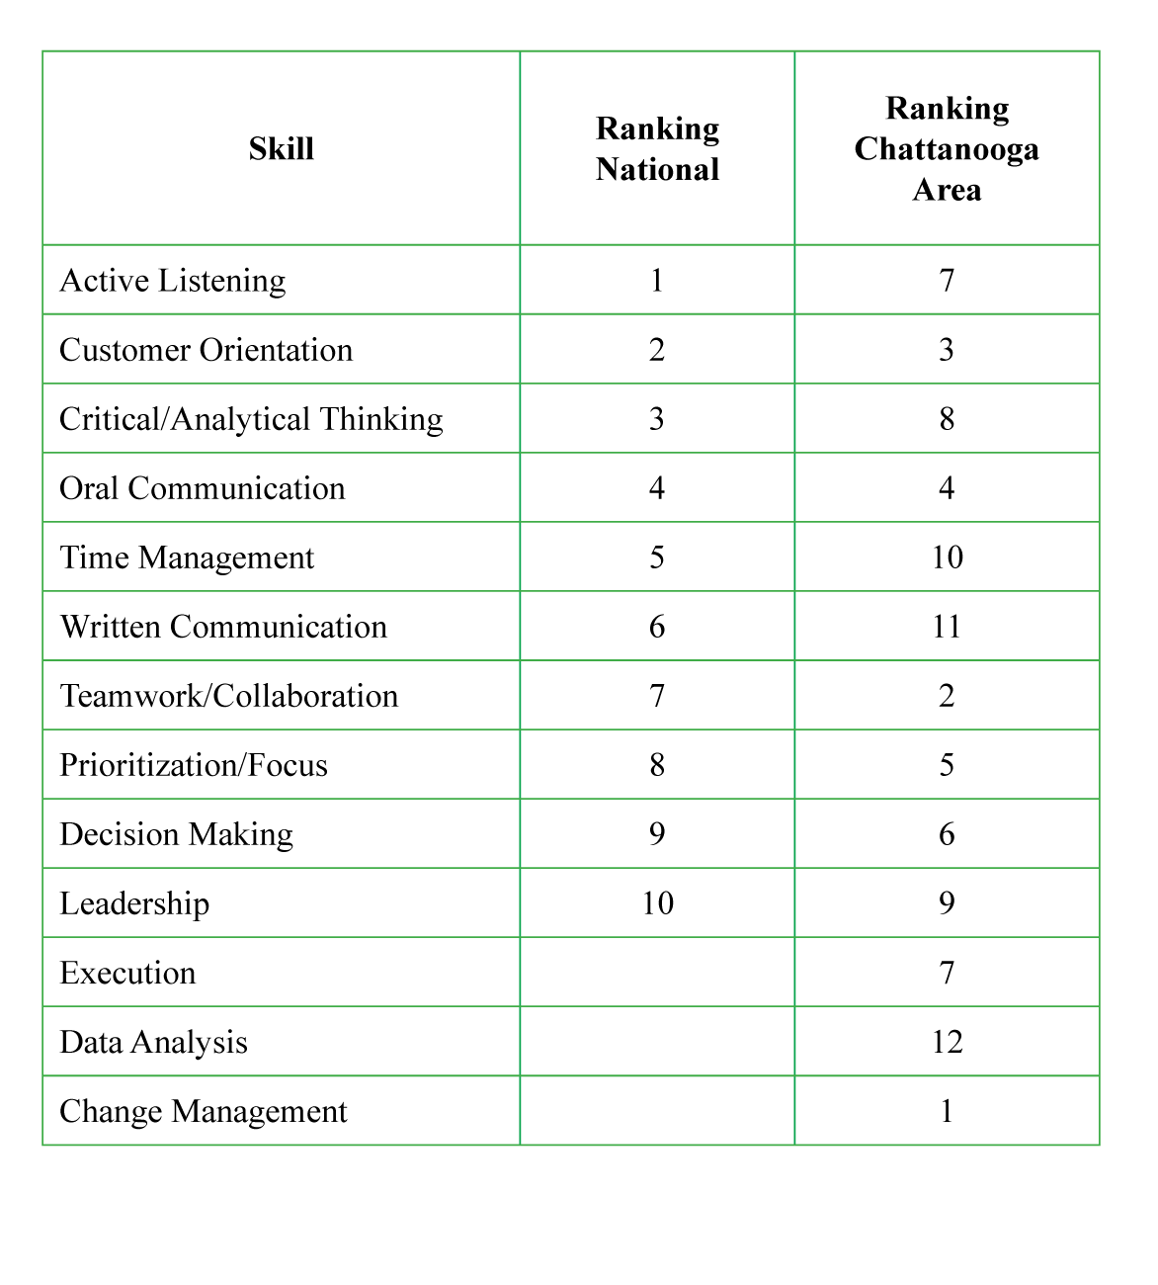
Identification of Critical Workforce Skills, Dr. John Dorris, The University of Tennessee at Chattanooga, July 12, 2011.
Earnings and Occupations

When individuals reach quality competency and skill, Recovery 2020 (2013) reports, educational attainment is expected to increase earnings to some extent. In most cases, earnings are affected by educational attainment award as well as by the type of education. Educational attainment does not, however, assure higher wages and higher lifetime earnings. Depending upon the occupation, individuals with less education may earn higher wages and accrue greater lifetime earnings than do better-educated individuals. In general, however, educational attainment provides better employment opportunities and better preparation for the future.
In The College Payoff, Anthony P., Steven J. Rose, and Ban Cheah (2011) concluded that
No matter how you cut it, more education pays. . . . There is a sizeable economic return for going to college and earning at least a two- or four-year degree. The 33% of bachelor’s-degree holders who continue on to graduate school and professional schools have even more prosperous futures ahead. Moreover, the differences in earnings between those who go to college and those who do not is growing, meaning that post-secondary education is more important than ever. (p. 20)

The Currency of Degrees
Research conducted at the Ross, Shen, Bedroussian, and Zhang (2013) indicated that an association exists between the “average years of schooling among the employed in a metropolitan area in terms of real GDP and real wages per worker” (p. 1). Justin Doubleday (2103) reports that whereas the unemployment rate in 2012 for bachelor’s-degree holders in 2012 was 4%, the unemployment rate for high-school graduates was 8.3% of high school graduates.

Return on Investment
When considering the relationship between educational attainment and GDP, projections for the Tennessee-Georgia MSA for five cycles, from 2011 to 2025, indicate an increase of 0.143 in average years of schooling. This educational increase signifies an increase in GDP of $635 per capita and an increase in real wages by $361.00 per capita as of 2025 (see Figure 1a). Considering Cortwright’s (2010) analysis of the State of Oregon—the scenario that 10,000 Oregon adults who have a high-school education complete a four-year degree. Oregon state income-tax receipts would increase by $8 million annually and key public service programs would decline by $9 million. The return on investment (ROI) for the state of Oregon would be $17 million annually.
Trostel’s (2007) work enumerates the effects of college attainment over a lifetime:
A. Total government spending decreases by $10,000 per degree from public institutions.
B. The net fiscal effect per degree from public institutions increases by more than $481,000.
C. Educational attainment has a positive impact on earnings and health. College graduates as head of households, for example, accumulate 90 times more financial wealth than do head of households who are high-school dropouts.
- Individuals with more education live an average of nine years longer than high-school dropouts, and they are less likely to suffer from cardiovascular disease, cancer, lung disease, diabetes, and other afflictions.
E. In households where the head earns a bachelor’s degree or higher, 11% of boys and 7% of the girls are obese. In contrast, in households headed by an individual with less than a high-school education, 24% of the boys and 22% of the girls exhibit childhood obesity. More education makes a difference.
F. The incidence of such chronic health conditions as diabetes, cardiovascular disease, and kidney ailments is lower in individuals with higher-education degrees.
Measured by per-capita income, educational attainment explains 58% of a city’s success (CEO’s for Cities Talent Dividend report, 2012). Recovery’s, Job Growth, and Education Requirements Through 2020 by Georgetown University listed projections for 2020, as noted previously, highlights the opportunities for potential employment, which is a benefit if one makes appropriate preparation. In the Tennessee-Georgia MSA, on average, an individual who holds a postsecondary degree or higher generates approximately $104 thousand annually. In the tri-state region this results in a collective impact of $850 million. More education makes a difference. Indeed, each additional percentage point improvement in educational attainment is linked with $763 in per capita income. Sandra E. Black and Lisa M. Lynch report that workers with more education are more productive (8% in manufacturing; 12.4% in service occupations).

Tuition Reimbursement and Experiential Credit
Employees may provide tuition reimbursement for an employee’s life experience. As a result, the employee earns equivalent college credit and the employer gains a return on investment. A current practice, called Prior Learning Assessment (PLA), is one in which the employee prepares a portfolio that is evaluated by the American Council on Education (ACE). If the portfolio meets college-level standards, ACE issues an official transcript. Depending upon the policy of the educational institution, the credit may be applied toward a degree. Assuming a cost of approximately $385.00 per credit hour (in-state tuition varies by institution), for example, an individual who is awarded up to 6 credit hours may save up to $1,695.00 after adjusting for the cost of the portfolio and evaluation. Assuming out-of-state tuition (varies by institution) at $564 per credit hour, the savings amounts to $2,948. Such savings benefit the employer’s tuition-reimbursement budget, providing more funds for the education of additional employees. Furthermore, in 2010, the Council for Adult and Experiential Learning (CAEL) reported that adults who did not earn PLA credit take 2.5 times longer to complete their degrees than do adults who earn PLA credit. In other words, earning PLA credit significantly reduces the amount of time needed to reach the degree.
Systemic, Sustainable, Quality Workforce
Only when we take advantage of developing the type of robust, sustainable talent pool being promoted by the Chattanooga Region Talent Dividend will we reap the fiscal and societal impact of educational attainment and assure a vital regional economy. The Lumina Foundation (2013) reports that, “unfortunately, it is a long-standing reality that educational success is very uneven. In particular, low-income and first-generation students, racial and ethnic minorities, immigrants and adults have traditionally been underrepresented among college students and graduates” (p. 4). This is a troubling trend. Figure 11 shows the growth of the Latino population that harbors a rich source of skills and talents.
Some individuals argue that because there are so many different reasons that would-be graduates drop out of college, higher education cannot solve the retention dilemma. But potential graduates do have one thing in common: Each of them dreams of completing a degree. When every adult with some college credit attains a degree, the nation will succeed, employer needs will be met, and everyone will benefit from the ROI.
The Chattanooga Region’s Talent Dividend goal is 8,171 additional post-secondary-degree graduates by 2015. (The regional goals are reset every 3 years.) The Lumina Foundation goal is 60% of the nations adults by 2025. The first step in reaching these goals is to remain committed to them. Together, higher education working with business and industry can make this possible—and, consequently, latent untapped talent will develop continuously. Our communities and our nation will be strengthened by a sustainable quality workforce—because talent changes everything.

Figure 11
Predicting the Next Wave
400
375
350
325
300
275
250
2000
2010
2020
2030
2040
2050
12.5%
Of total pop.
16.3%
Of total pop.
17.8%
Of total pop.
20.1%
Of total pop.
22.3%
Of total pop.
24.4%
Of total pop.
35,305,818
50,477,594
73,055,000
87,858,000
102,560,000
59,756,000
281,421,906
308,745,538
335,805,000
363,584,000
391,946,000
Total Population
Latino Population
Data for 2000 & 2010: US Census Bureau, “Overview of Race Hispanic Origin: 2010,” 2010 Census Brief, issued March 2010, p. 4. Projections for 2020 and beyond: U.S. Census Bureau, 2004, “U.S. Interim Projections by Age, Sex, Race, and Hispanic Origin.”
References

American Community Survey. (2011). No longer available. Originally at www.census.gov/.../education/…/Ewert–Wildhagen_prisoner_education_...

AMJ Kidney Dis, 2011, August, 58(2): 228-234

Black, S. E., & Lynch, L. M. (1996). Human-Capital Investments and Productivity. The American Economic Review, Vol. 86, No. 2, Papers and Proceedings of the Hundredth and Eighth Annual Meeting of the American Economic Association San Francisco, CA, January 5-7, 1996 (May, 1996), pp. 263-267.

Carnevale, A. P., Rose, S. J., & Cheah, B. (2011). The college payoff: Education, occupations and lifetime earnings. Washington, DC: Georgetown University Center on Education and the Workforce.

CEOs for Cities. (2012). Talent Dividend video. Retrieved from http://vimeo.com/
41372550, on October 28, 2013.

CEO’s for Cities Talent Dividend Report. Retrieved from http://www.ceoforcities.
org/tags/view/talent%20dividend on February 2, 2012).

Choi, I. A., Weekley, C. C., Chen, S. C., Li, S., Tamura, M. K., Norris, K. D., & Shlipak, M. G. (2011). Association of educational attainment with chronic disease and mortality: The kidney early evaluation program (KEEP). Retrieved from http//www.ncbi.nlm.nih.gov/pmc/articles/PMC3144262 on November 11, 2013).

Cortright, J. (2010). The fiscal return on education: How educational attainment drives public finance in Oregon. Impresse Economics, November 2009. Retrieved from depts.washington.edu/uwcel/e3_obc/fiscal_return_on_education.pdf‎, on November 18, 2013.

Council for Adult and Experiential Learning (CAEL). (2010). Fueling the race to post-secondary success.

DeVol, R. C., Shen, I., Bedroussian, A., & Zhang, N. (2013). A matter of degrees: The effect of educational attainment on regional economic prosperity. Washington, D.C.: Milken Institute.

Dorris, J. P. (2011). Identification of critical workforce skills in the Chattanooga region [unpublished dissertation]. Proquest Dissertations and Theses.

Doubleday, J. (2013). Earnings gap narrows, but college education still pays. Chronicle of Higher Education [online version], October 7, 2013.

Guerrieri, V., Hartley, D. A., & Hurst, E. (2012). Within-city variation in urban decline: The case of Detroit. Federal Reserve Bank of Cleveland Working Paper no. 12–05.
Hawkins, S. (2010). Education vs. incarceration. Retrieved from http://prospect.org/article/education-vs-incarceration, on October 30, 2013.

Isaacs, J. B., Sawhill, I. V., and Haskins, R. (2008). Getting ahead or losing ground: Economic mobility in America [online version]. Washington, DC: Brookings Institution Press. Retrieved November 18, 2013, from http://www.brookings.
edu/~/media/Research/Files/Reports/2008/2/economic%20mobility%20sawhill/02_economic_mobility_sawhill_foreword.PDF

Johnson, R. E. (2010). The economic impact of higher education. Retrieved November 11, 2013, from http://www.becker.edu/presidentjohnsonblog/
uncategorized/the-economic-impact-of-higher-education/

Lewin, T. (2010, September 21). Value of college degree is growing, study says. New York Times [electronic version]. Retrieved November 11, 2013, from htttp://www.nytimes.com/2010/09/21/education/21college.html?_r=0

A Stronger Nation Through Higher Education, (4th ed.). (2013). Lumina Foundation.

New England Public Policy Center. (2007). The fiscal impacts of college attainment (Working Paper No. 07-2): Boston, MA: P. A. Trostel.

NewPublicHealth. (2012, August 28, 2012). Retrieved November 18, 2013, from http://www.rwjf.org/en/blogs/new-public-health/2012/08/better_
educationhea.html

Renn, R. M. (2010, October 20). Core city educational attainment. Retrieved October 28, 2013, from http://www.urbanophile.com/2010/10/20/core-city-educational-attainment/

Schaerer J. W. Chattanooga Region Talent Dividend Initiative. Unpublished work.
Analytics via Telestrian Data Terminal (www.telestrian.com), retrieved January 2014.

Sifferlin, A. (2012). CDC: Higher income and education levels linked to better health. Retrieved October 30, 2013, from http://healthland.time.com/2012
05/16/cdc-higher-income-and-education-levels-linked-to-better-health/

U.S. Bureau of Labor Statistics. (2012). Current Population Survey. Retrieved from http://www.bls.gov/emp/ep_table_education_by_train.htm, on November 18, 2013.

Copyright © 2013 by John W. Schaerer.

